## **Design and Implementation of a**

## **Payroll Management System**

**Developed in Python TK Inter+MySQL**

|  |  |  |
| --- | --- | --- |
| **S.NO** | **Name** | **ID** |
| 1 |  |  |
| 2 |  |  |
| 3 |  |  |
| 4 |  |  |
| 5 |  |  |

Abstract:

“Employee Database And Payroll Management System” is designed to make the existing manual system automatic with the help of computerised equipment and full-edged computer software, fulfilling their requirements, so that their valuable data and information can be stored for a longer period with easy access and manipulation of the same. The required software is easily available and easy to work with. This application can maintain and view computerised records without getting redundant entries. The project describes how to manage user data for good performance and provide better services for the client.

About The Project

A Payroll Management System Project In Python Code is a system used by companies to help manage the computation, disbursement, and reporting of employees’ salaries efficiently and accurately.So most of organizations are using this feature for employee benefits. We have top options for this project like Automated & Normal. In the automated system employee salary is automatically calculated based on the working hours. The advantage is without manual process easily find out the exact salary for all employees.

The proposed project “Payroll Management System” has been developed to overcome the problems faced in the practicing of manual system. This software is built to eliminate and in some cases reduce the hardships faced by the existing system. Moreover this system is designed for particular need of the company to carry out its operations in a smooth and effective manner. This web application is reduced as much as possible to avoid errors while entering data. It also provides error message while entering invalid data. It is user-friendly as no formal knowledge is required to use the system. Human resource challenges are faced by every organization which has to be overcome by the organization. Every organization has different employee and payroll management needs. Therefore I have design exclusive Employee and payroll Management System that are adapted to the organization’s Managerial Requirements.

Purpose

The purpose of this document is to describe the functionality and specifications of the design of a web application for Managing Employees and their payroll. The expected audiences of this document are the developers and the admin of the web application. Now with the help of this system the admin has the information on his finger tips and can easily prepare a good record based on their requirements. Finally, we can say that this system will not only automate the process but save the valuable time of the manager or the admin, which can be well utilized buy his institute. This will be an additional advantage and management of power based on their free time from his normal duty

Modules:

Admin The Admin gets logged in by valid username and password. Admin can add new Employee, add new Department, add new Pay Grade for the employees. Admin can set the ‘from’ and ‘to’ date worked by an employee in a department with specific pay grade. The Admin can generate an automated monthly salary of an employee. The admin can view all the past records of any recorded employee.

Advantages

• It is cost effective as the user control the web application himself and does not go for professional service.

• It saves time as it speeds up every aspect of the employee database management and payroll process with a range of automated features.

• It is secure as the employee database and the payroll process is managed by the admin in house rather than sending private information to a third party.

• Validating procedures and checks restrict user from making mistakes.

• The software is easy to use and is user friendly so no expertise is required.

• The calculations are automated so no chance of error.

Disadvantages

• It requires large database.

FEASIBILITY STUDY

After identifying the scope of the project, the feasibility study is needed to be carried out. It is basically keeping the following points in mind.

Building the software for meeting the scope:

This software has met the scope. As there is no data involved in the system, processing on the file, and the behaviour of this project is already identified and bundled in quantitative manner. The processing of this software is very simple as it has been designed in Python language and it has been well divided into several functions according to the need.

Technically feasible:

This software is very much technically feasible. This software is very much concerned with specifying equipment and the software will successfully satisfy almost all the admin’s requirements. The technical need for this system may vary considerably but might include:

a. The facility to produce output in a given time.

b. Response time under certain conditions.

c. Ability to process data at a particular speed.

Therefore, the basic input/output of data is identified. So, the project can easily be build up and it will also be technically feasible.

State of Art: The project is very much within the state of art since the project is a WINDOWS based; it uses very modern and common technique. Beside it is very much modern and user friendly. It also works as middleware i.e. only in between the user and the file. So, it is completely a state of art project.

Financially Feasible: The project is very much financially feasible. The implementation and development cost of this software under the reach of any college. Moreover, it requires some training for the use. So, training cost can be neglected and the resources of this software are very much available. It also reduces the labour and extra cost to be paid for labour. So indeed, it is financially feasible.

Resources: As motioned earlier that the resources are easily available and the cost of training is almost negligible. Sometimes situations may arise when it may not be so much easy. For a person completely unaware of using a computer system could result in a training cost or for a very small organization the purchase of a computer, instalment of the system and other charges may lead to a difficult matter.

Benefits

* Easy to manage
* Time Saving
* Automated Process
* Bug Free Status
* Soft Copy Reports

Project Information’s

|  |  |
| --- | --- |
| **Project Name:** | Payroll Management System |
| **Language/s Used:** | Python (GUI) Based |
| **Python version (Recommended):** | 2.x or 3.x |
| **Database:** | MySQL |
| **Type:** | Python App |
| **Developer:** | Prabhjot Kaur |
| **Updates:** | 0 |

Database Name: Payroll

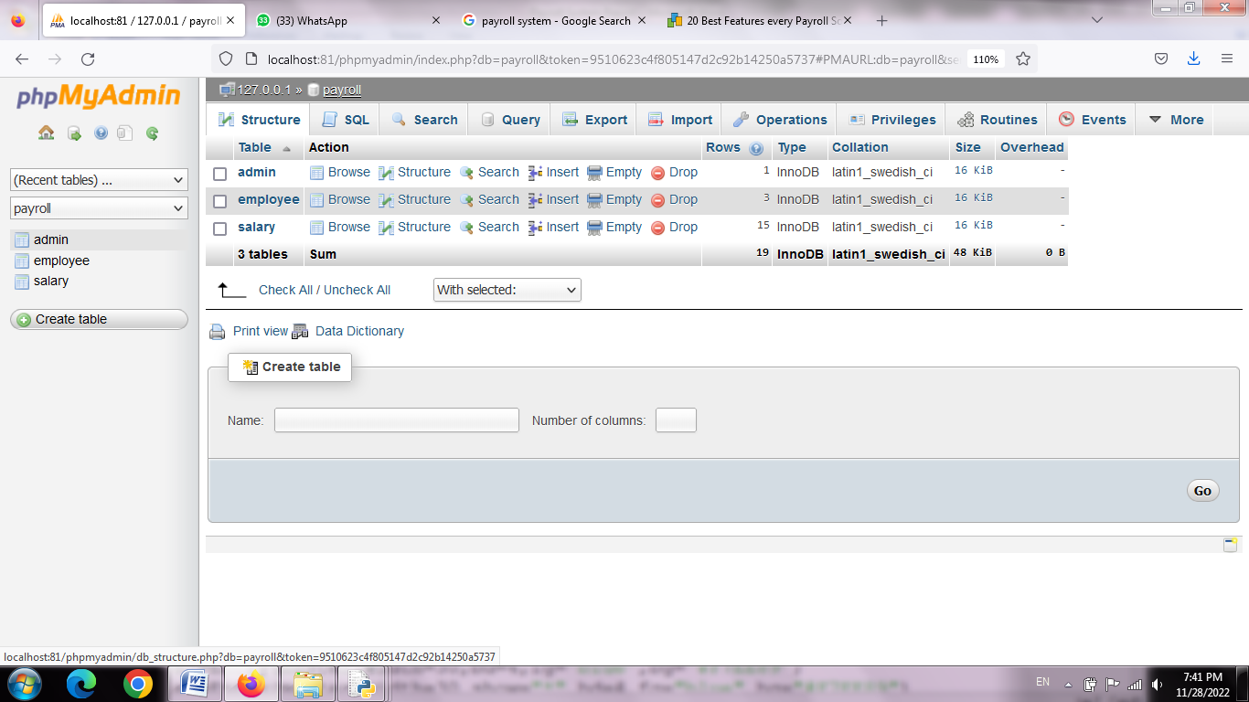

Admin Table:

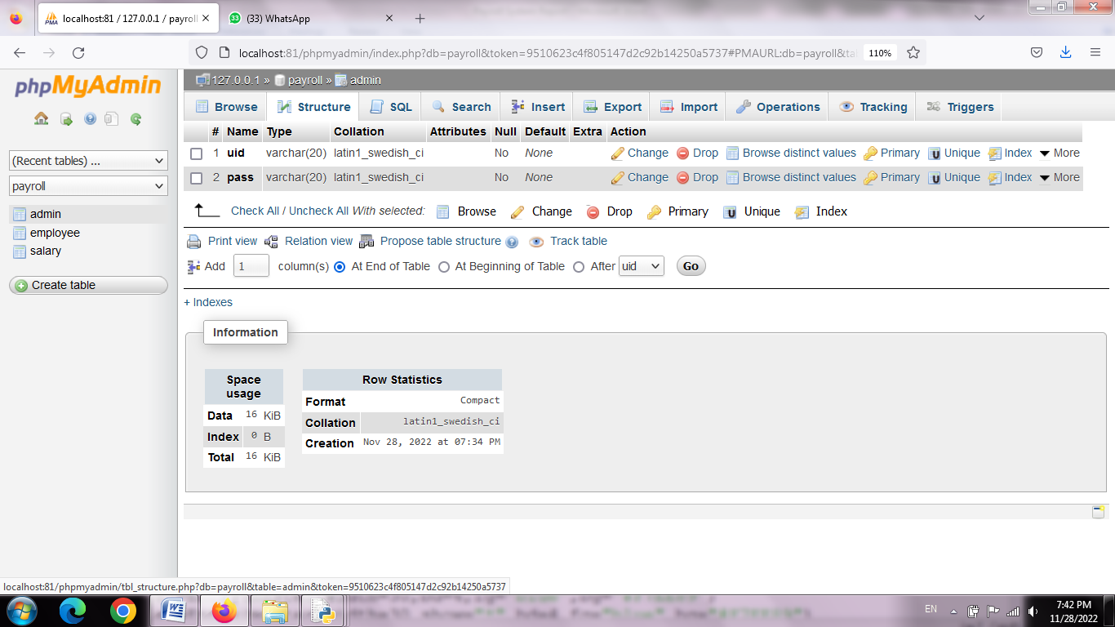

Employee Table

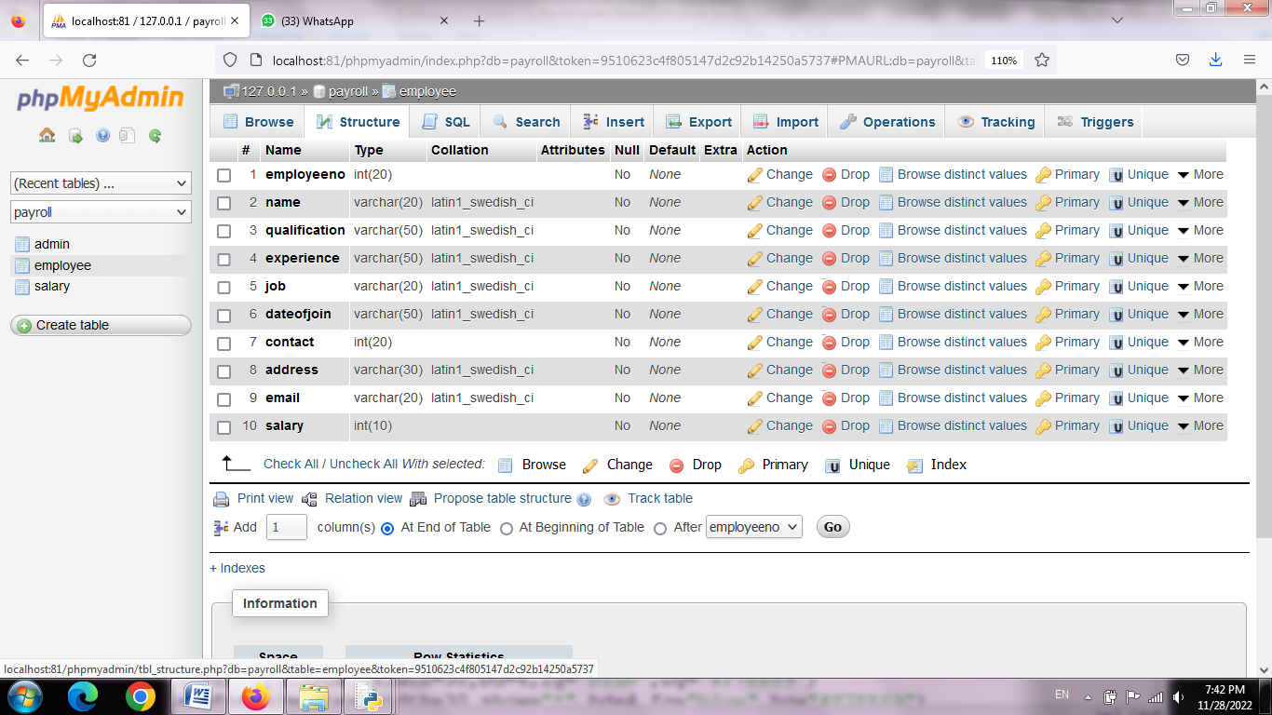

Salary Table

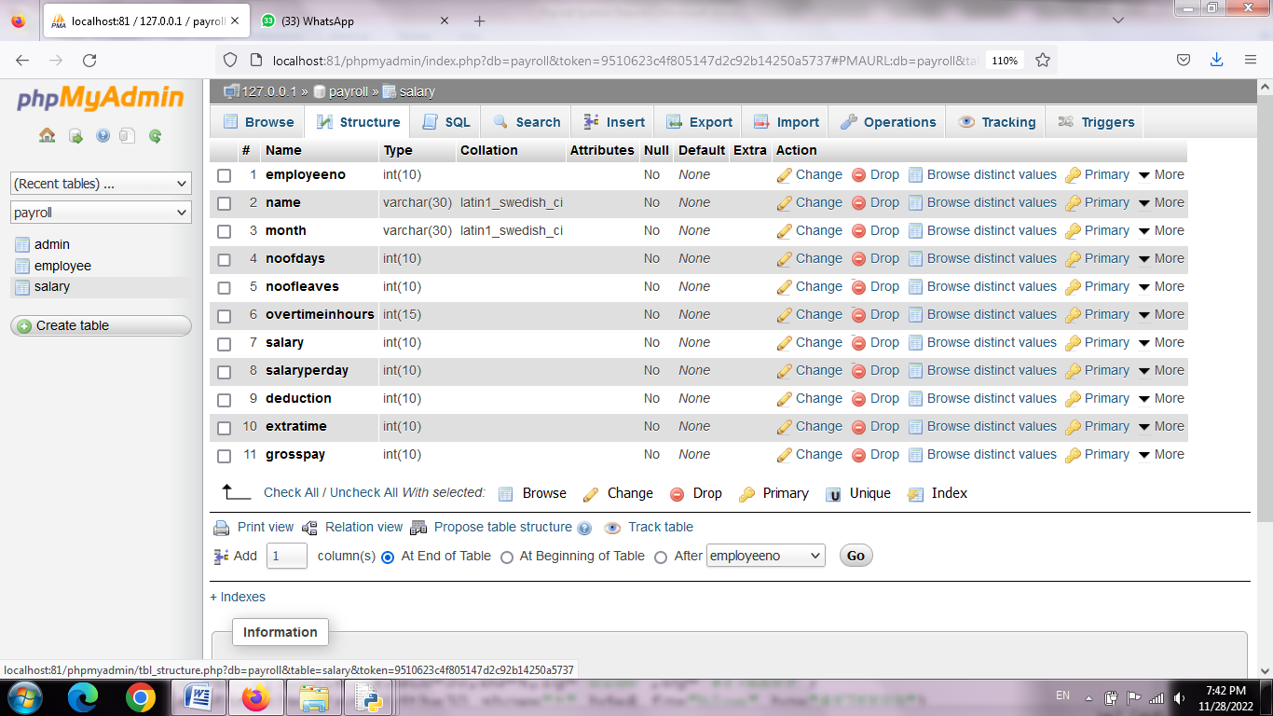

SQL Query

Admin Table

CREATE TABLE IF NOT EXISTS `admin` (

`uid` varchar(20) NOT NULL,

`pass` varchar(20) NOT NULL

) ENGINE=InnoDB DEFAULT CHARSET=latin1;

Employee Table

CREATE TABLE IF NOT EXISTS `employee` (

`employeeno` int(20) NOT NULL,

`name` varchar(20) NOT NULL,

`qualification` varchar(50) NOT NULL,

`experience` varchar(50) NOT NULL,

`job` varchar(20) NOT NULL,

`dateofjoin` varchar(50) NOT NULL,

`contact` int(20) NOT NULL,

`address` varchar(30) NOT NULL,

`email` varchar(20) NOT NULL,

`salary` int(10) NOT NULL

) ENGINE=InnoDB DEFAULT CHARSET=latin1;

Salary Table

CREATE TABLE IF NOT EXISTS `salary` (

`employeeno` int(10) NOT NULL,

`name` varchar(30) NOT NULL,

`month` varchar(30) NOT NULL,

`noofdays` int(10) NOT NULL,

`noofleaves` int(10) NOT NULL,

`overtimeinhours` int(15) NOT NULL,

`salary` int(10) NOT NULL,

`salaryperday` int(10) NOT NULL,

`deduction` int(10) NOT NULL,

`extratime` int(10) NOT NULL,

`grosspay` int(10) NOT NULL

) ENGINE=InnoDB DEFAULT CHARSET=latin1;

**Source Code:**

**adminlogin.py**

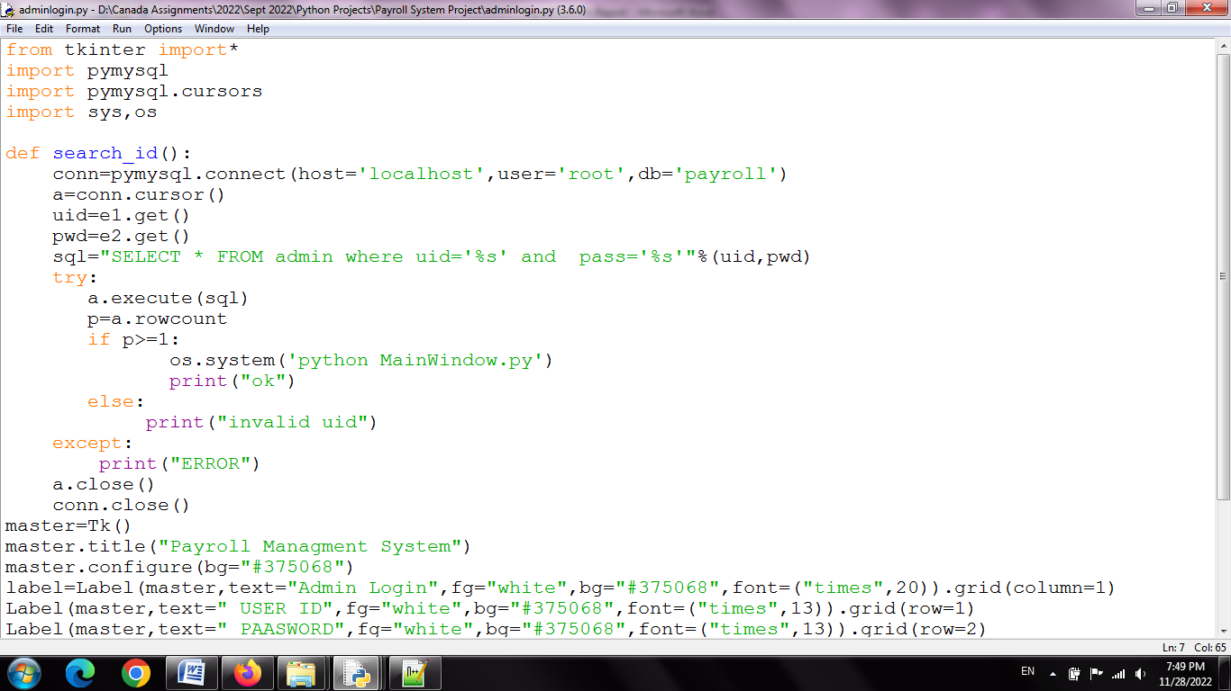

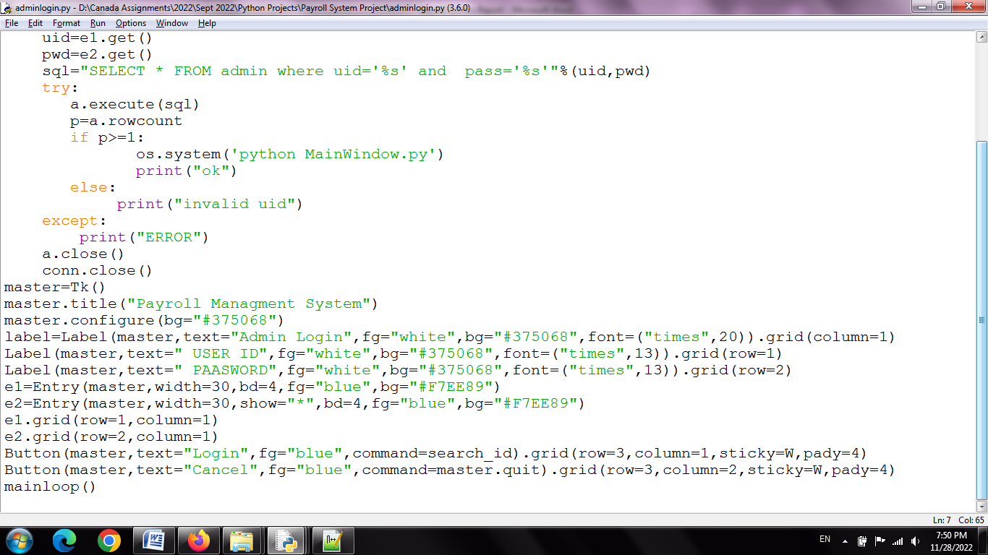

**mainwindow.py**

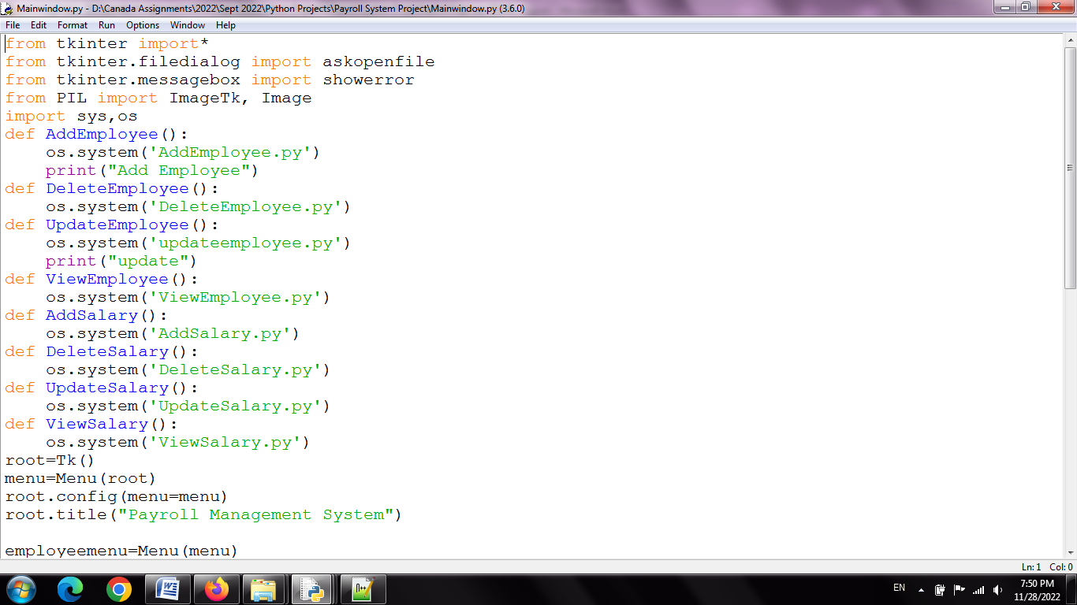

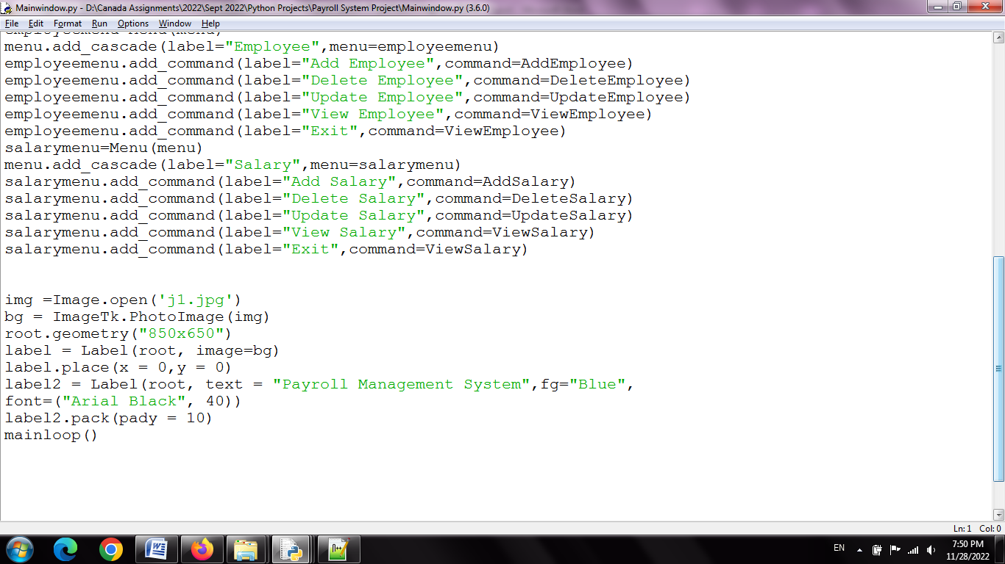

**addemployee.py**

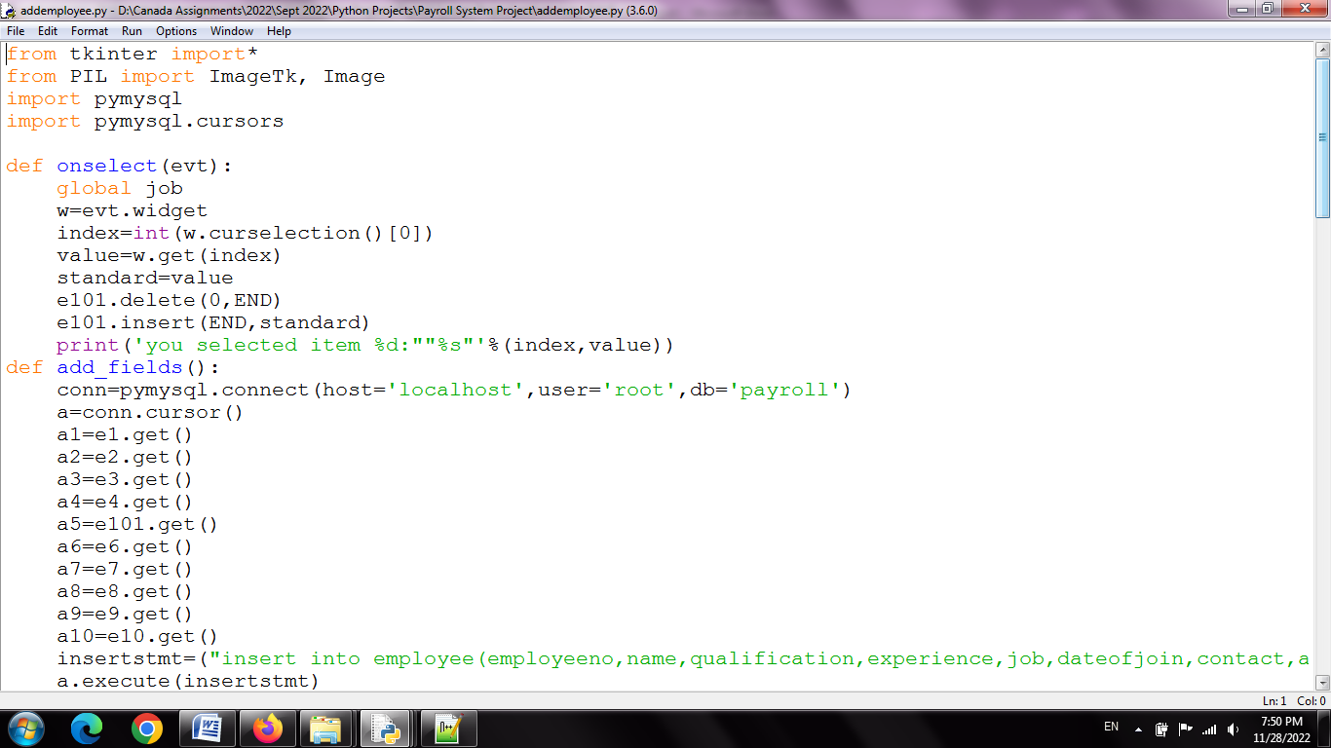

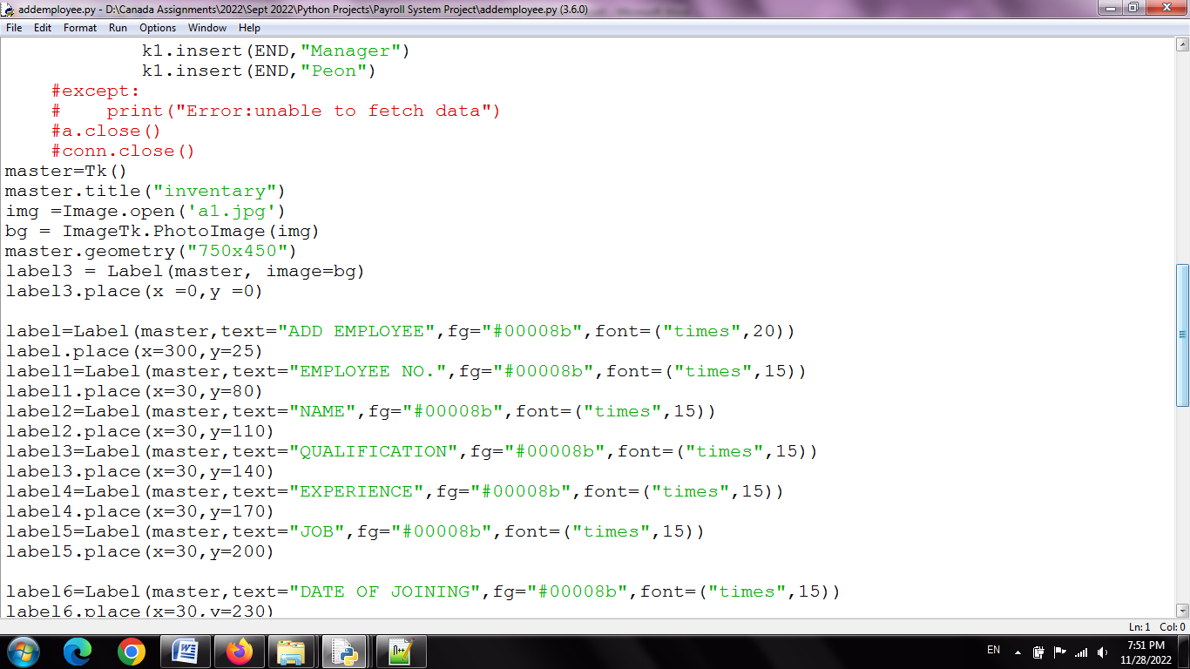

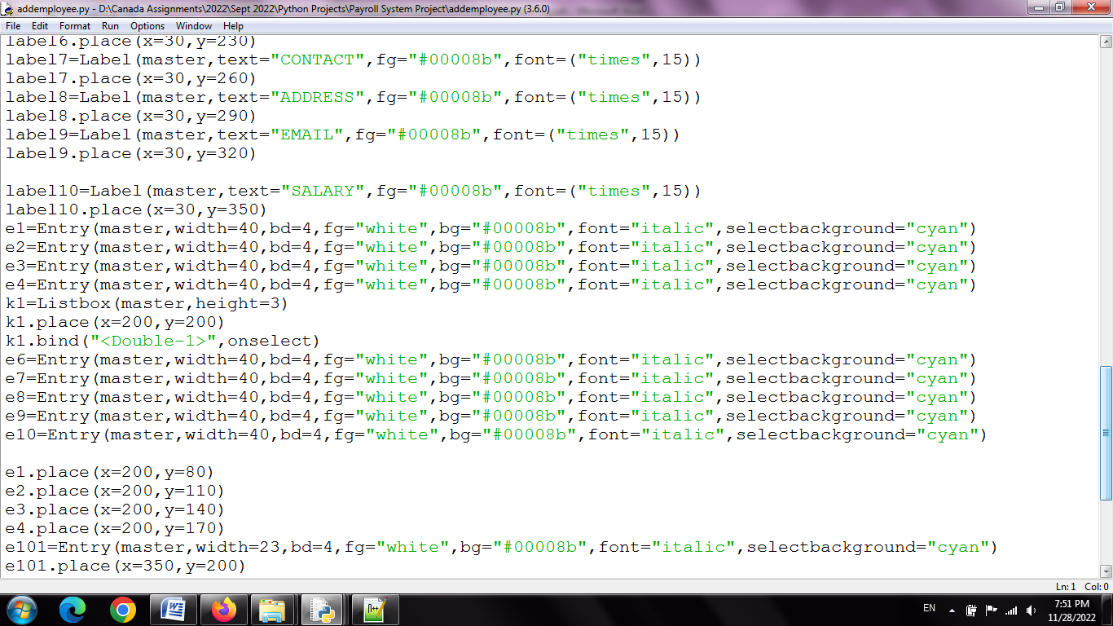

**addsalary.py**

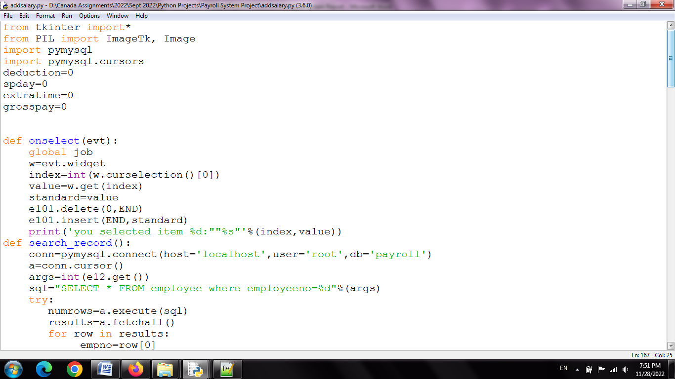

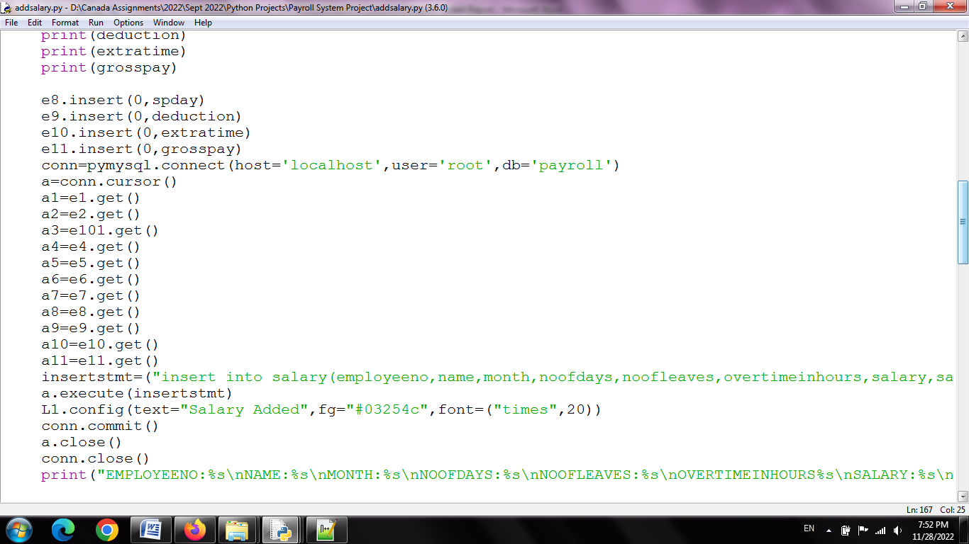

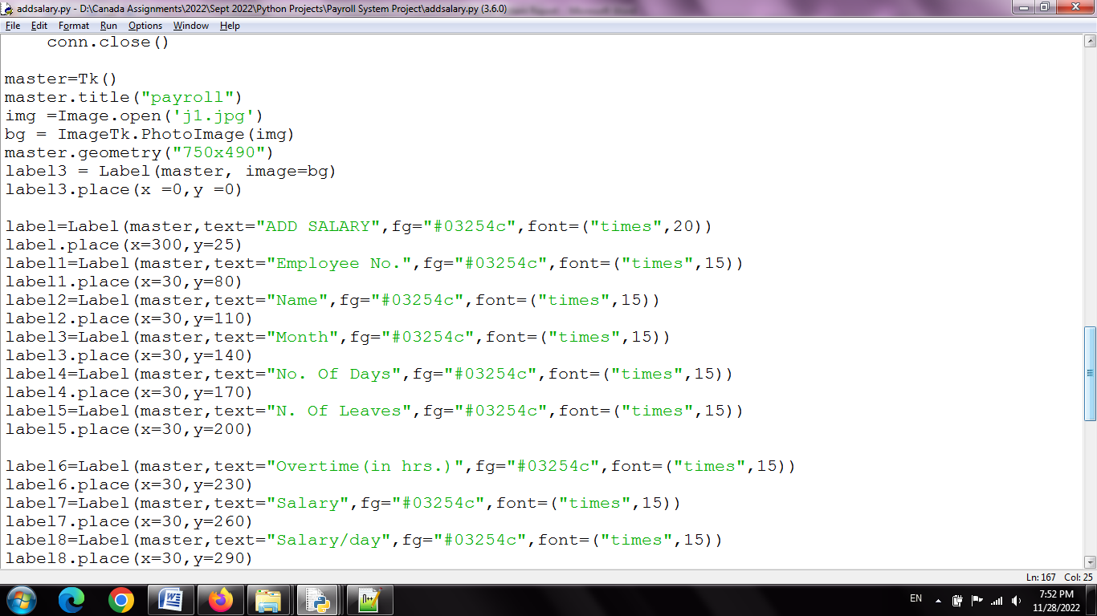

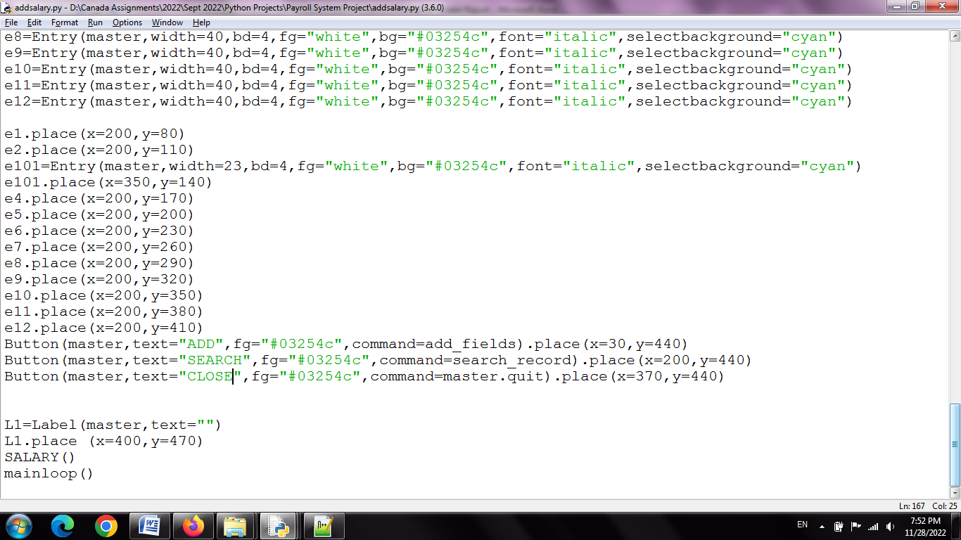

**Viewsalary.py**

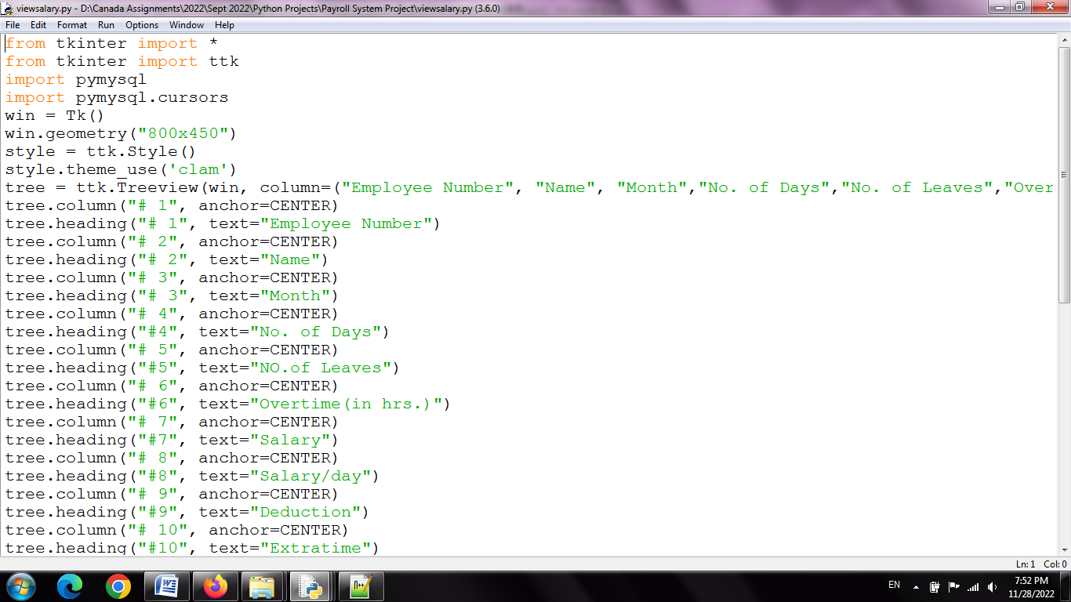

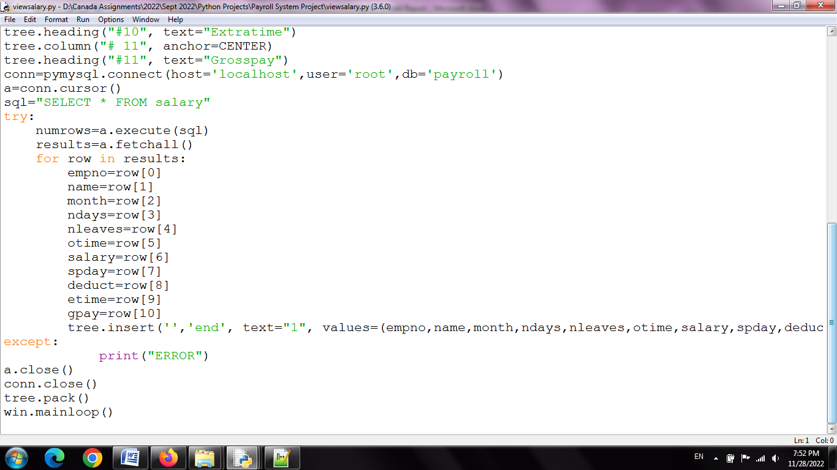

**Run The Application**

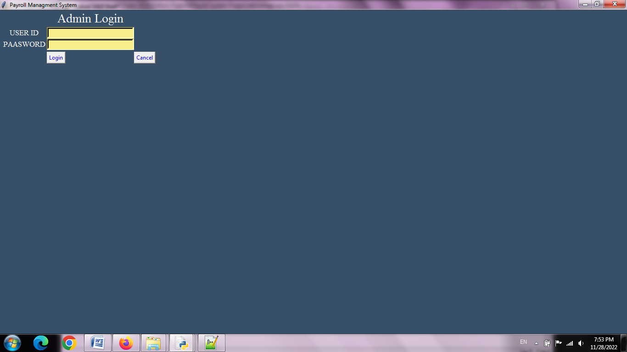

**type user name :admin**

**password:123**

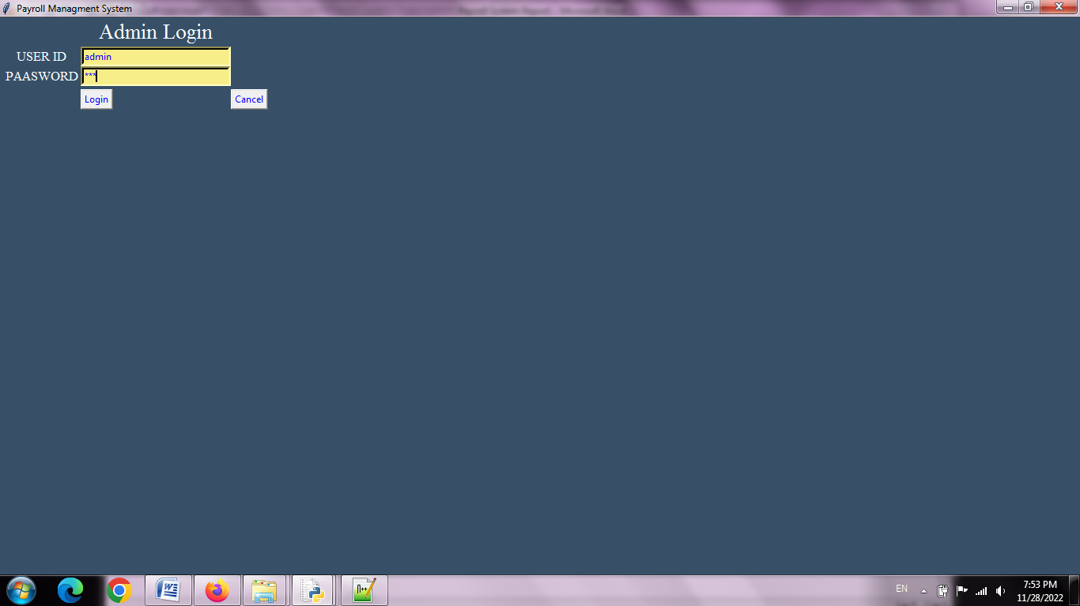

**Main Screen**

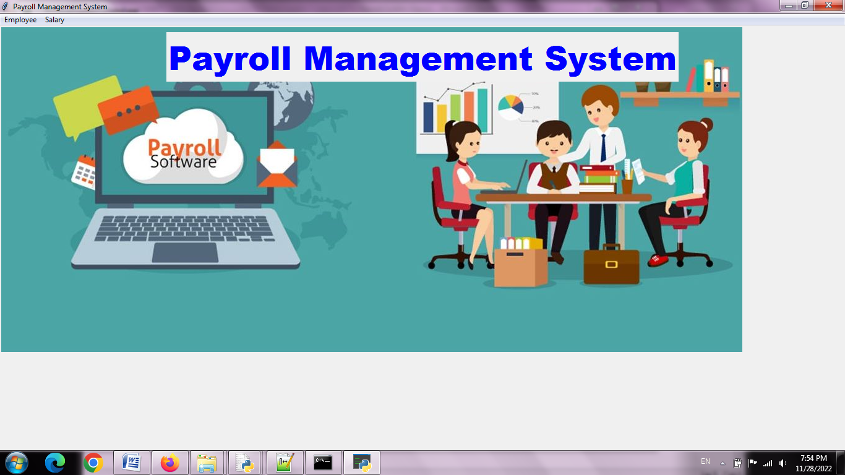

**Employee Menu**

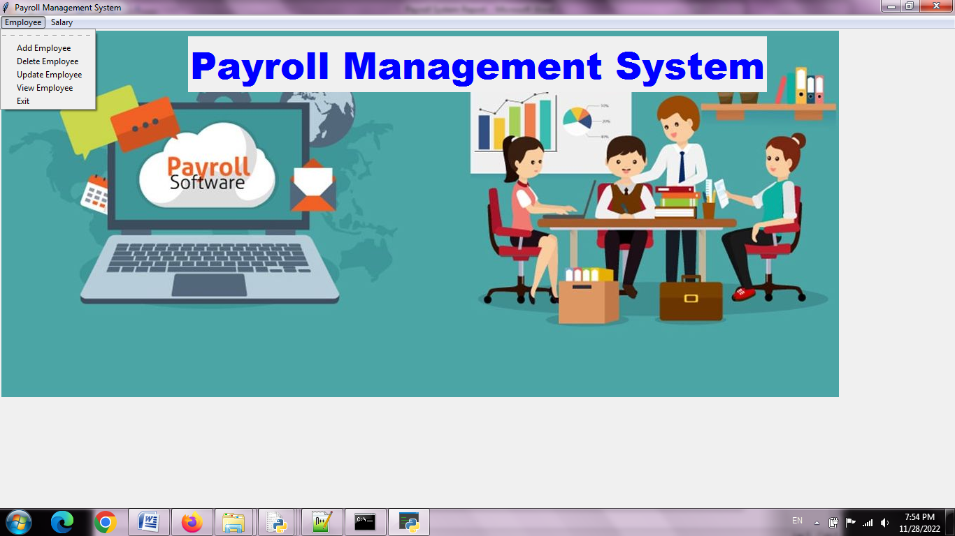

**Salary Menu**

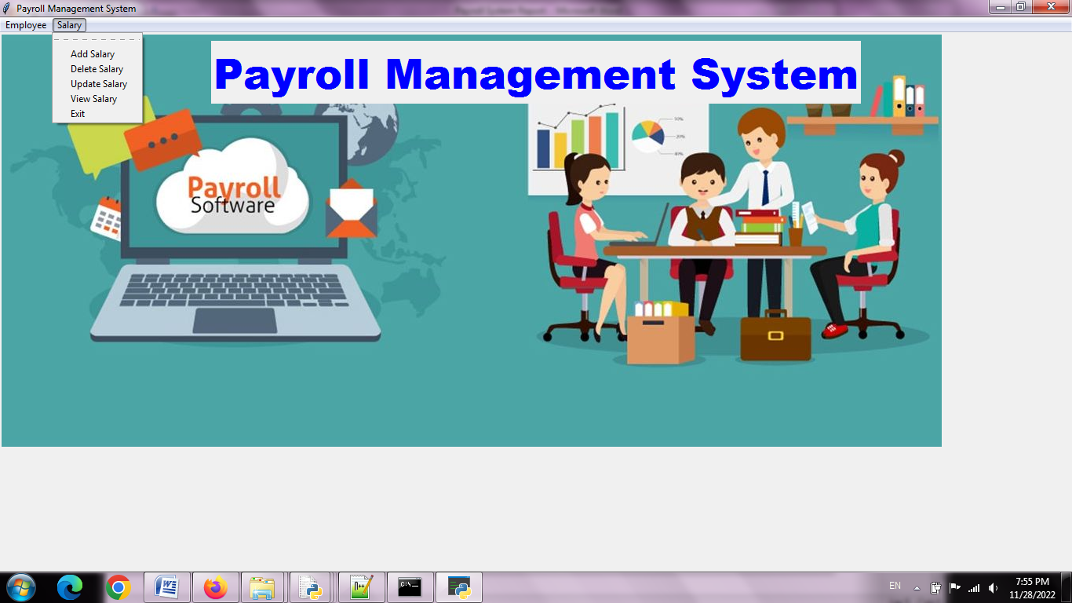

**AddEmployee**

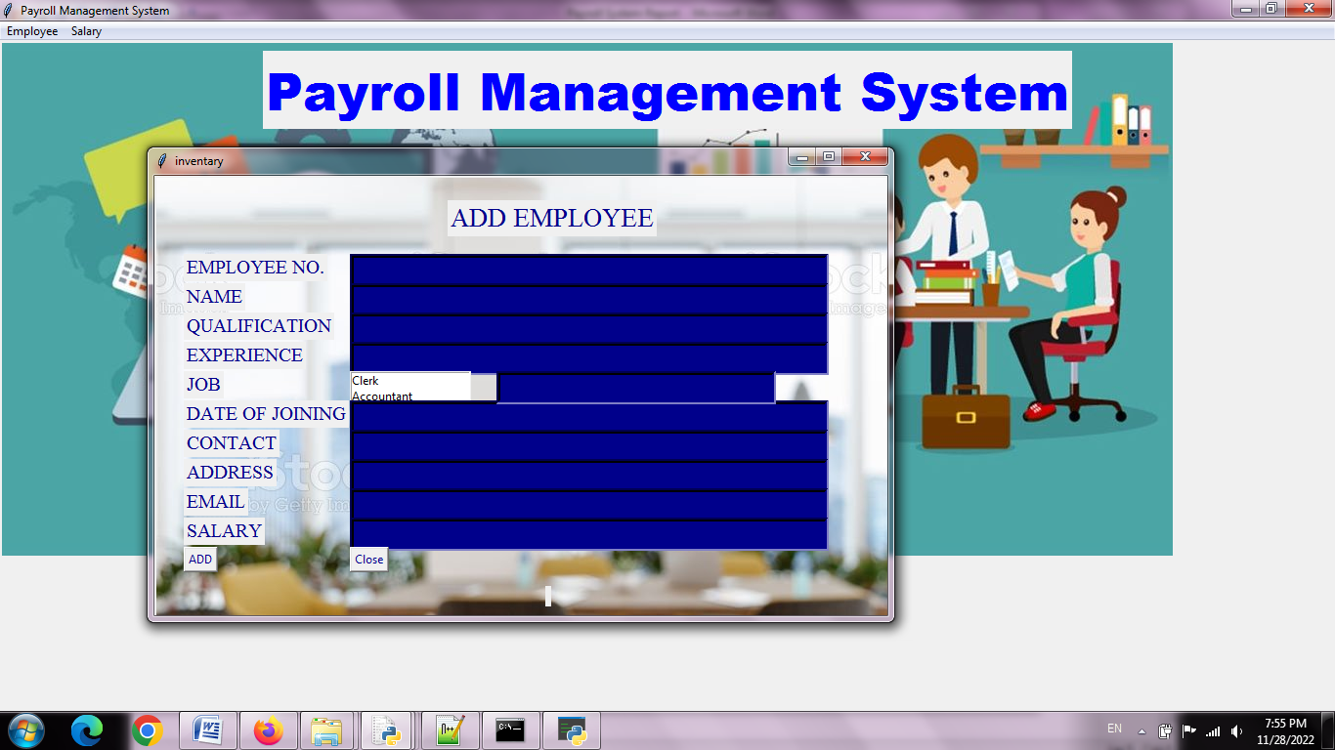

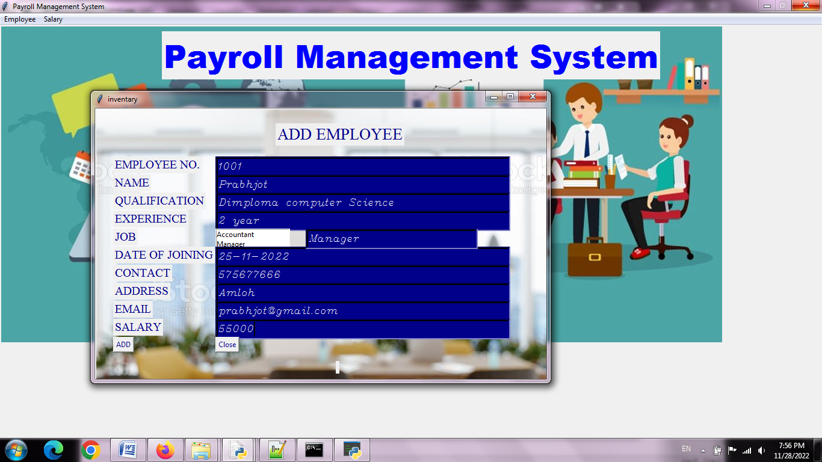

**Record Added**

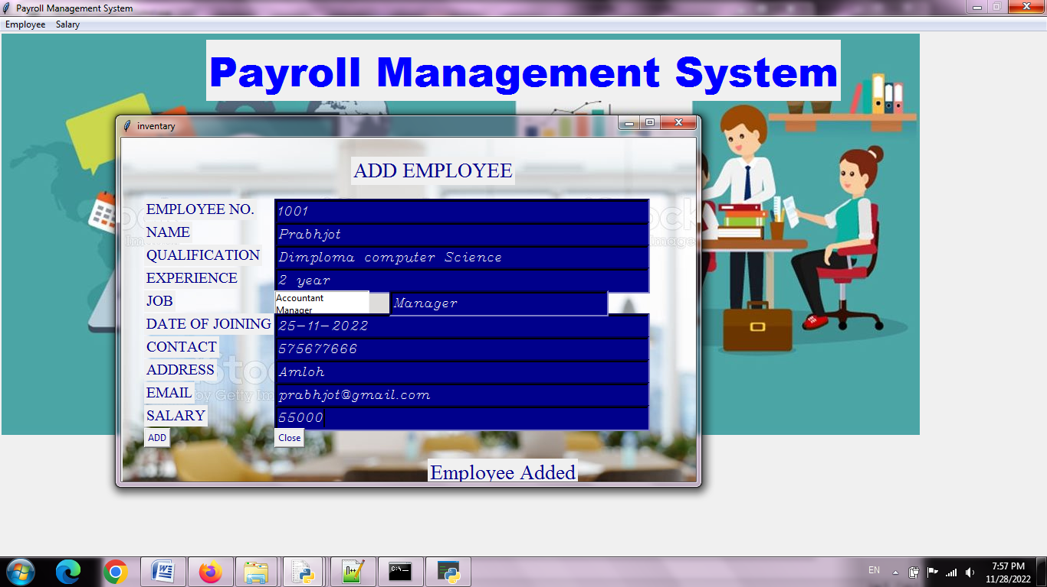

**View employee**

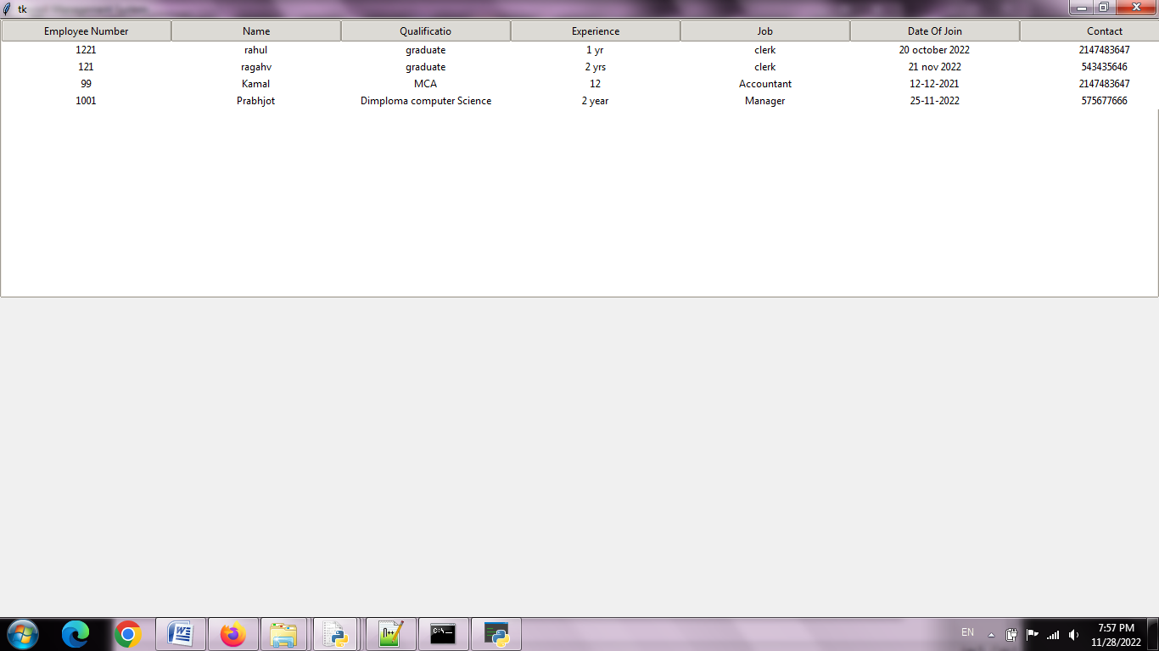

**Delete employee**

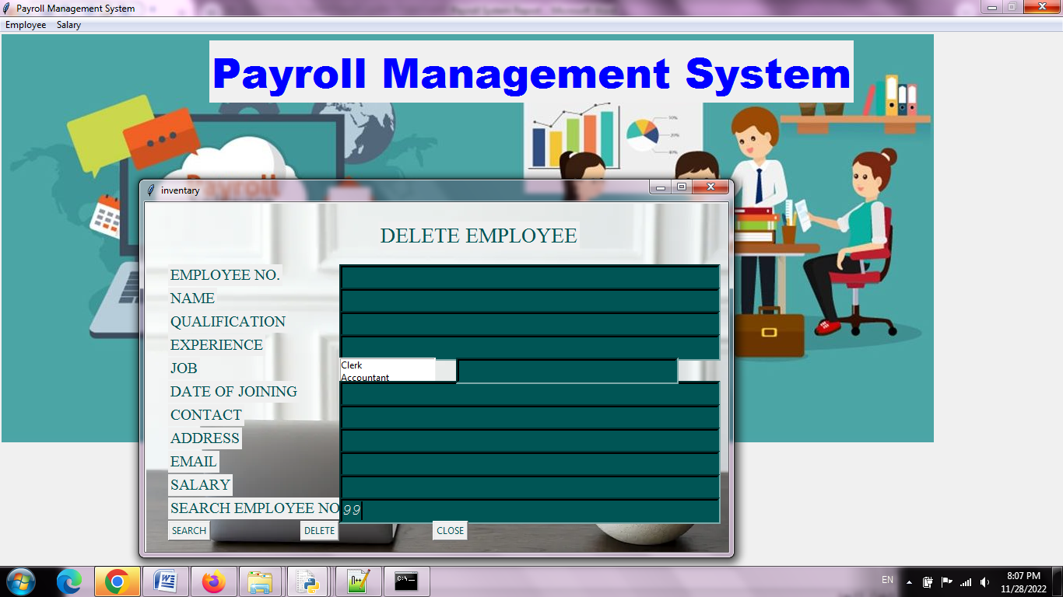

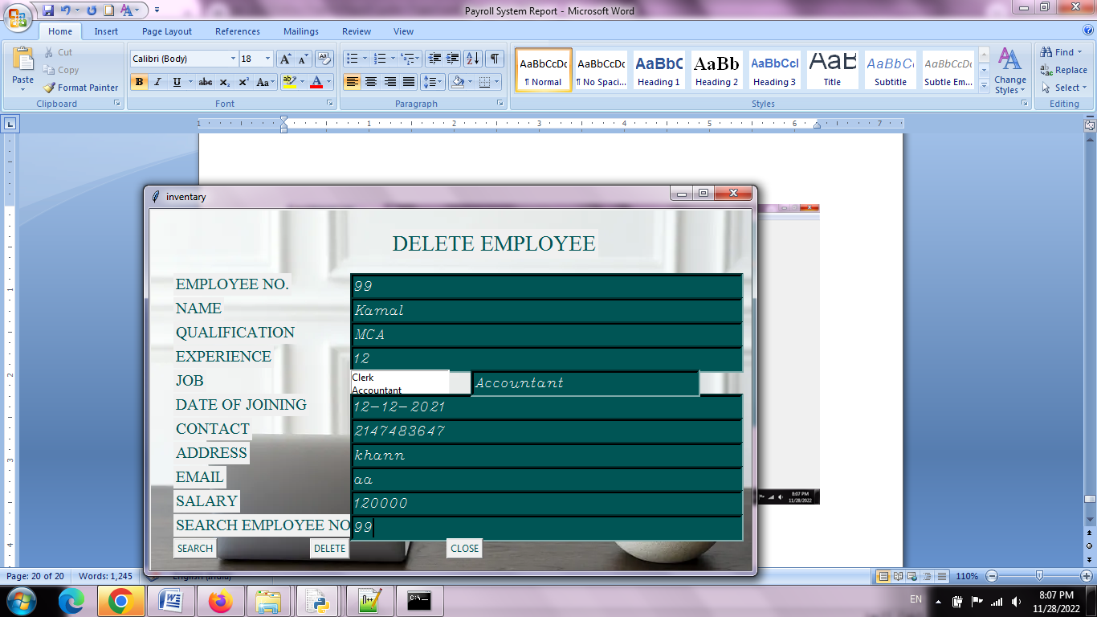

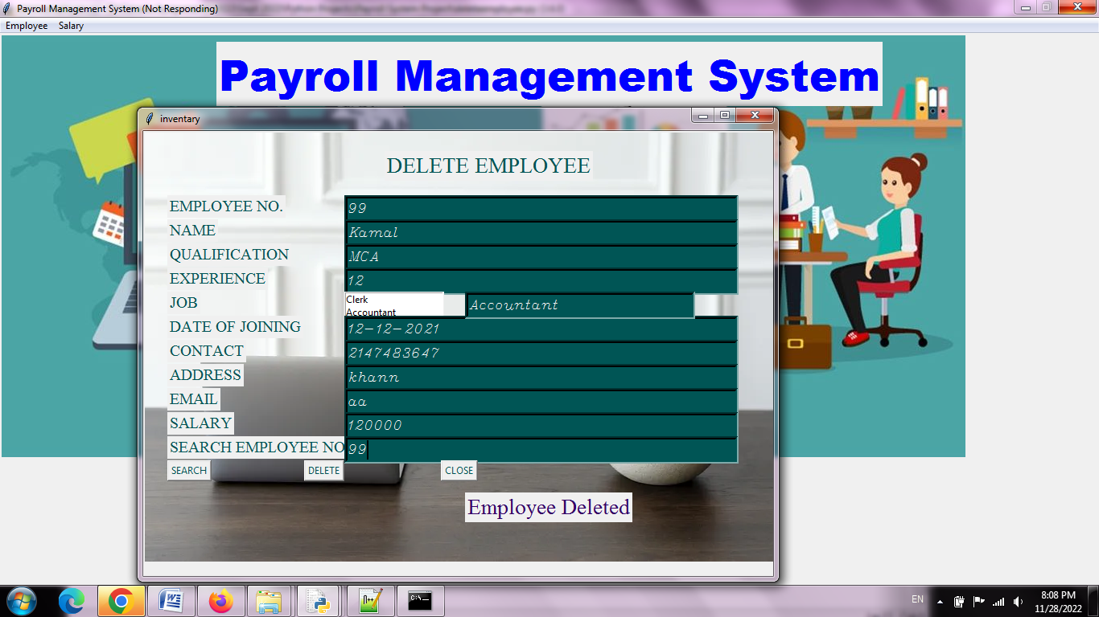

**View Employee**

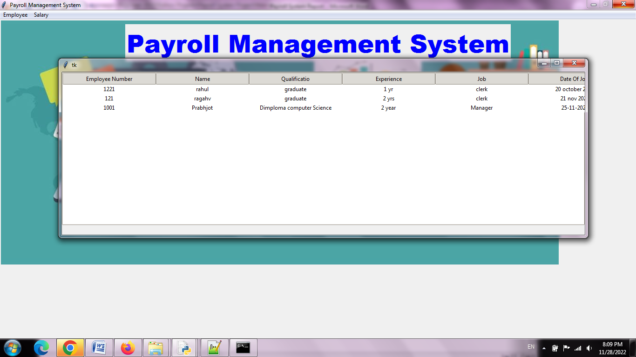

**Record Deleted**

**Add Salary**

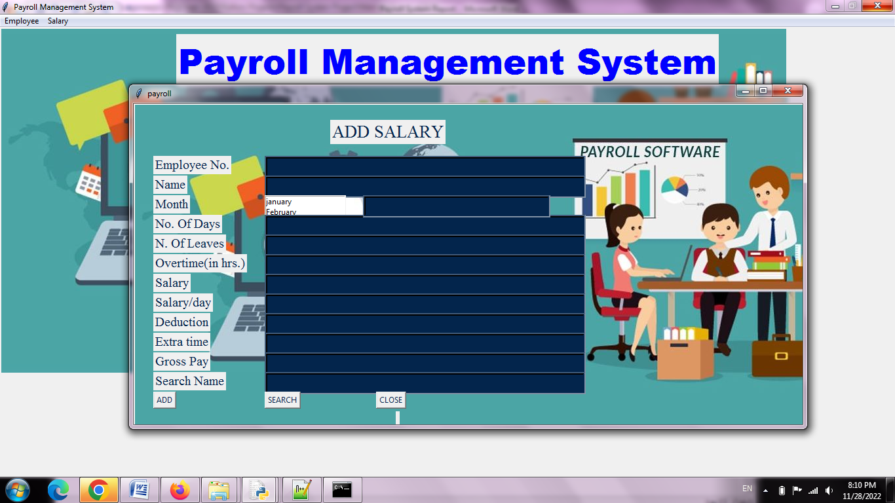

**Search the record of 1001**

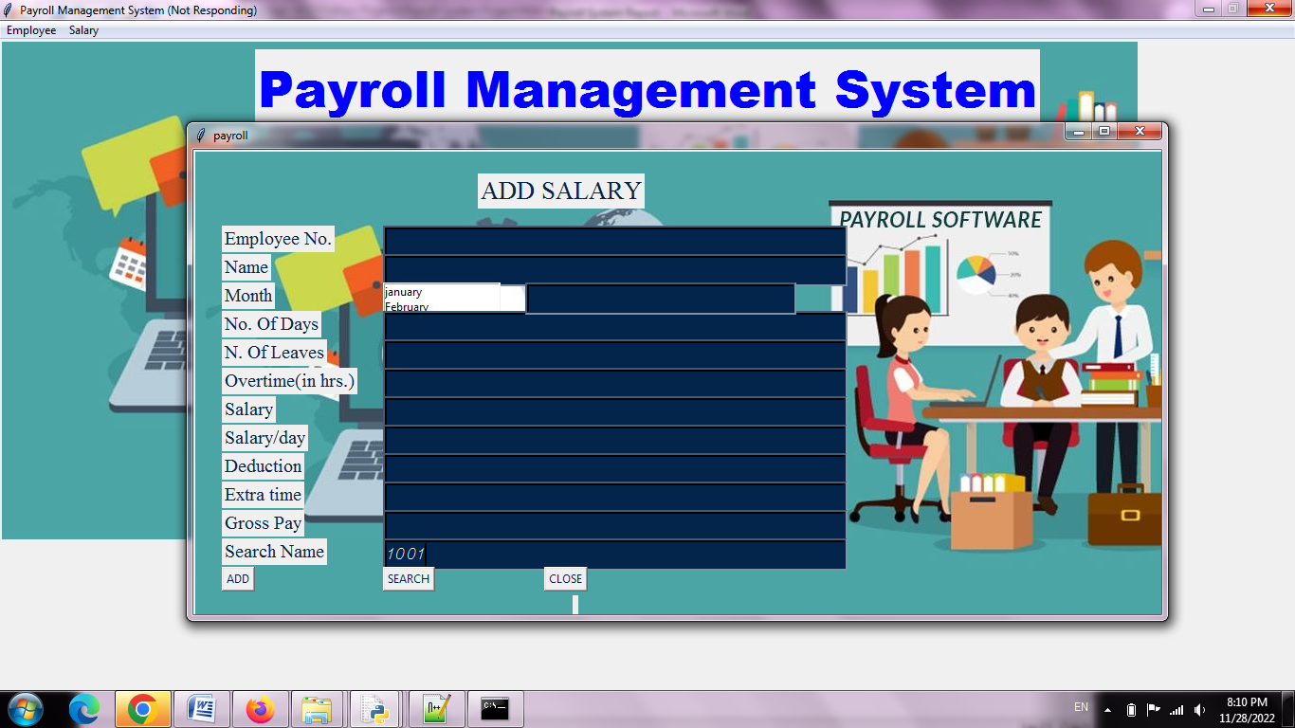

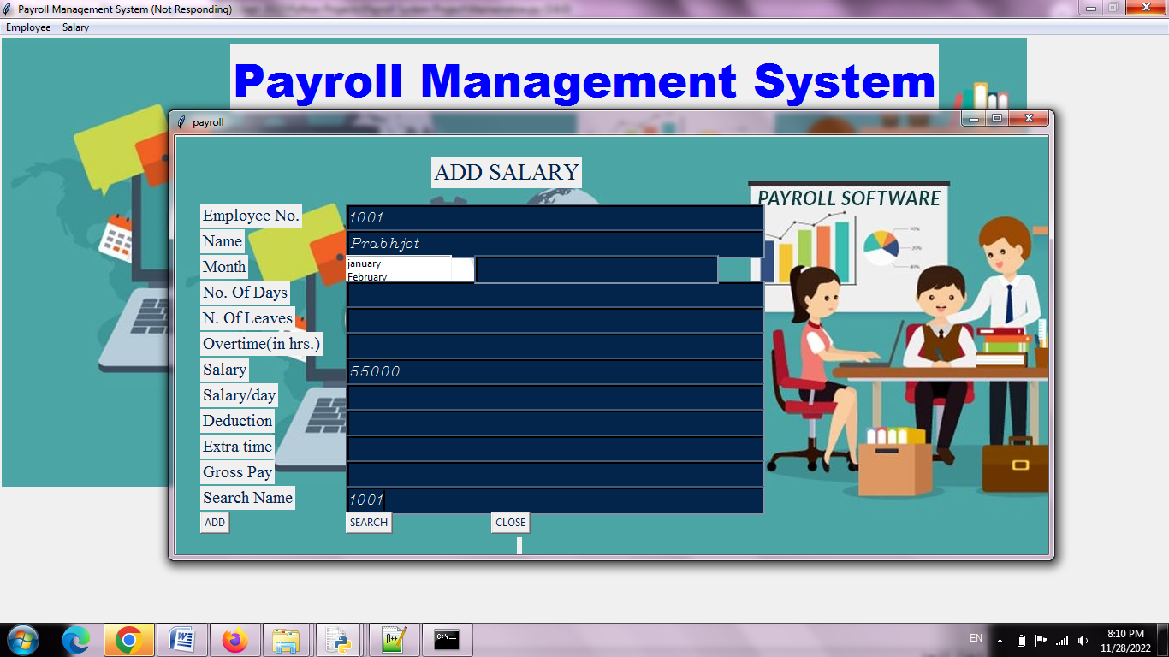

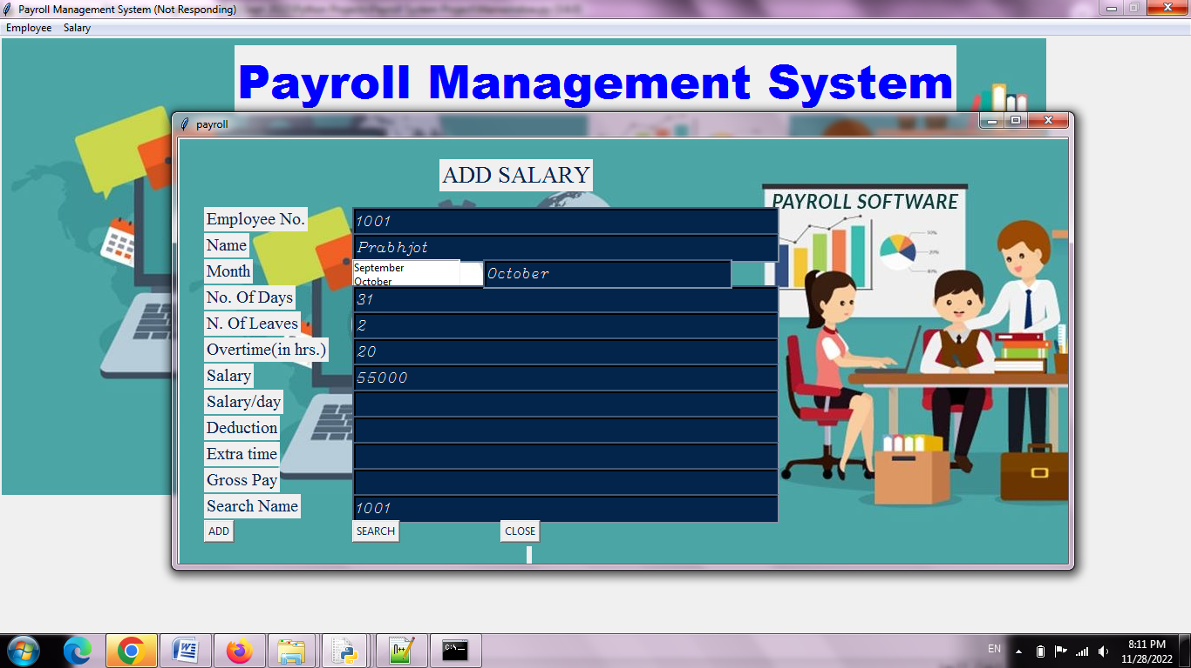

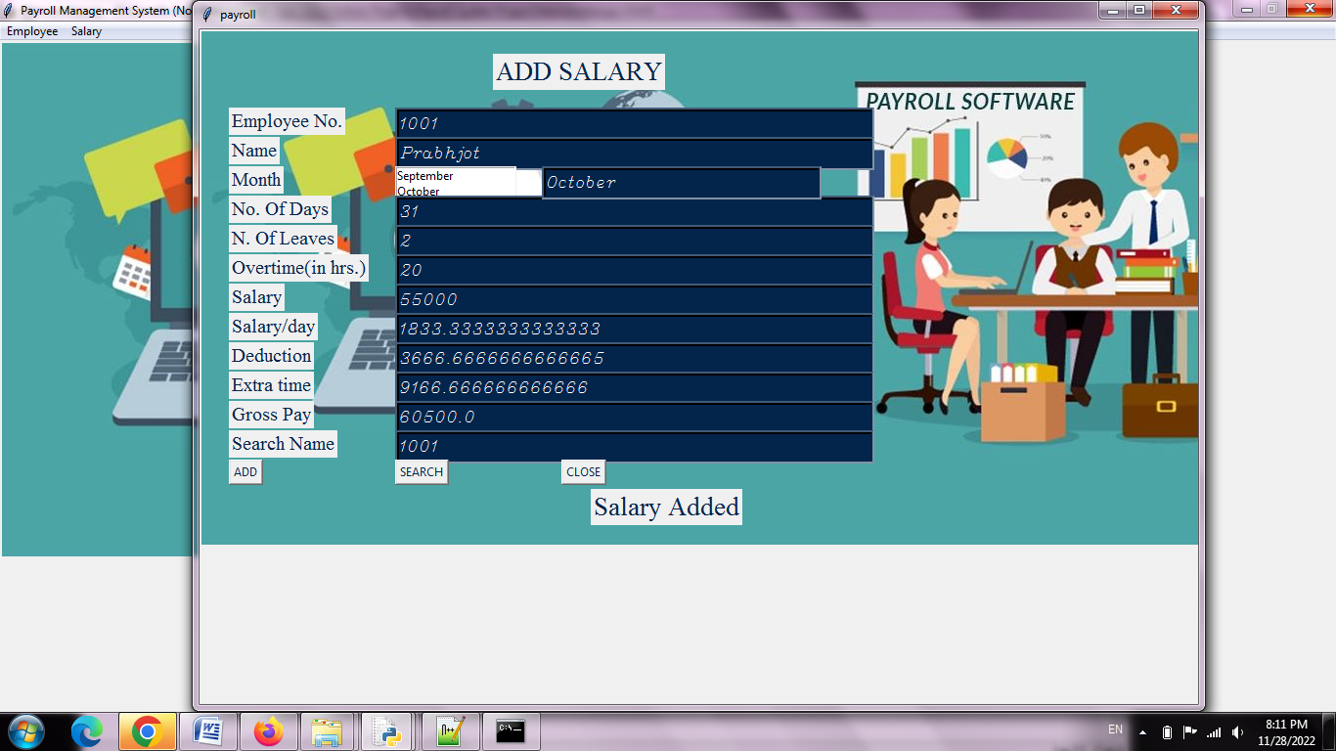

**View Salary**

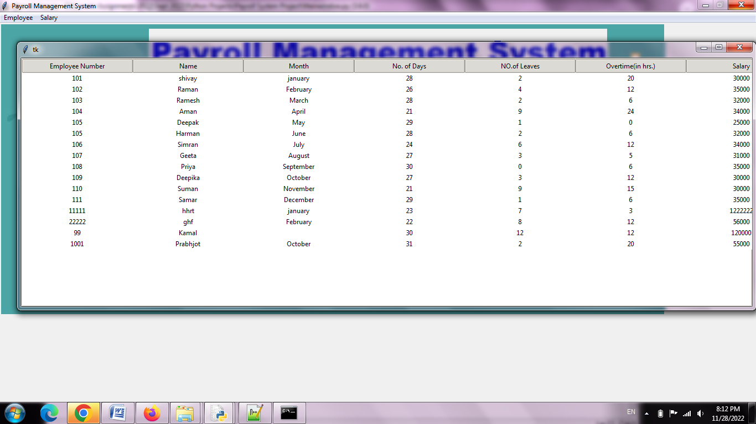

**Delete Salary**

